Stable distribution

Intro

A stable distribution is linear combination of two independent random variables has same distribution.

Parametrization

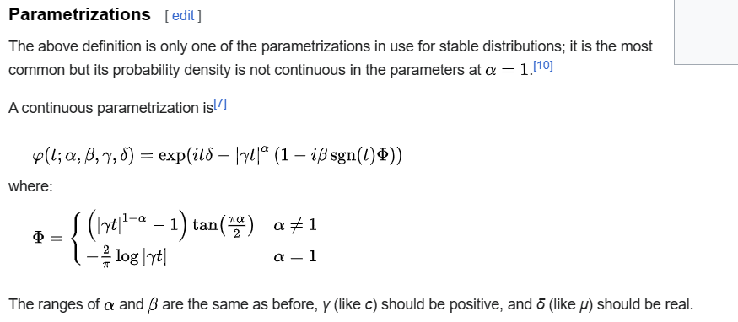

Parameter

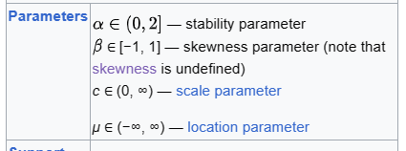

Support

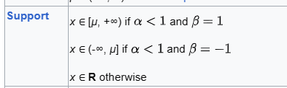

PDF



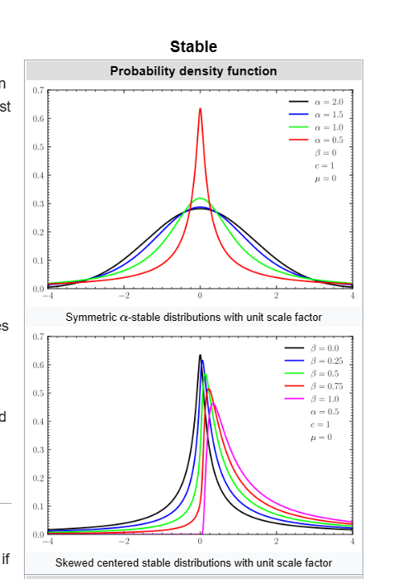

CDF

正在插入影像...

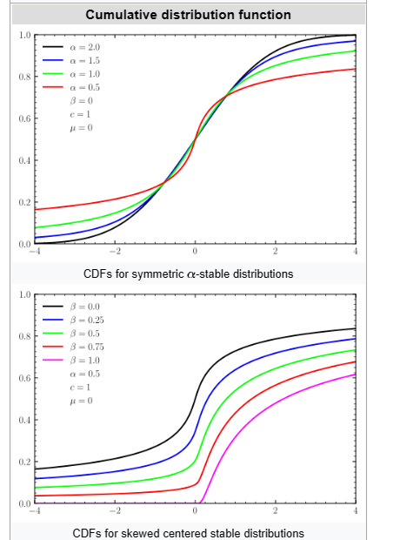

Expected Value

正在插入影像...

Variance



Mode

Median

Skewness



Ex. Kurtosis



Entropy



MGF



CF

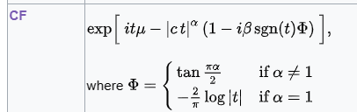

Moment

Ref

[Stable distribution - Wikipedia](https://en.wikipedia.org/wiki/Stable_distribution)